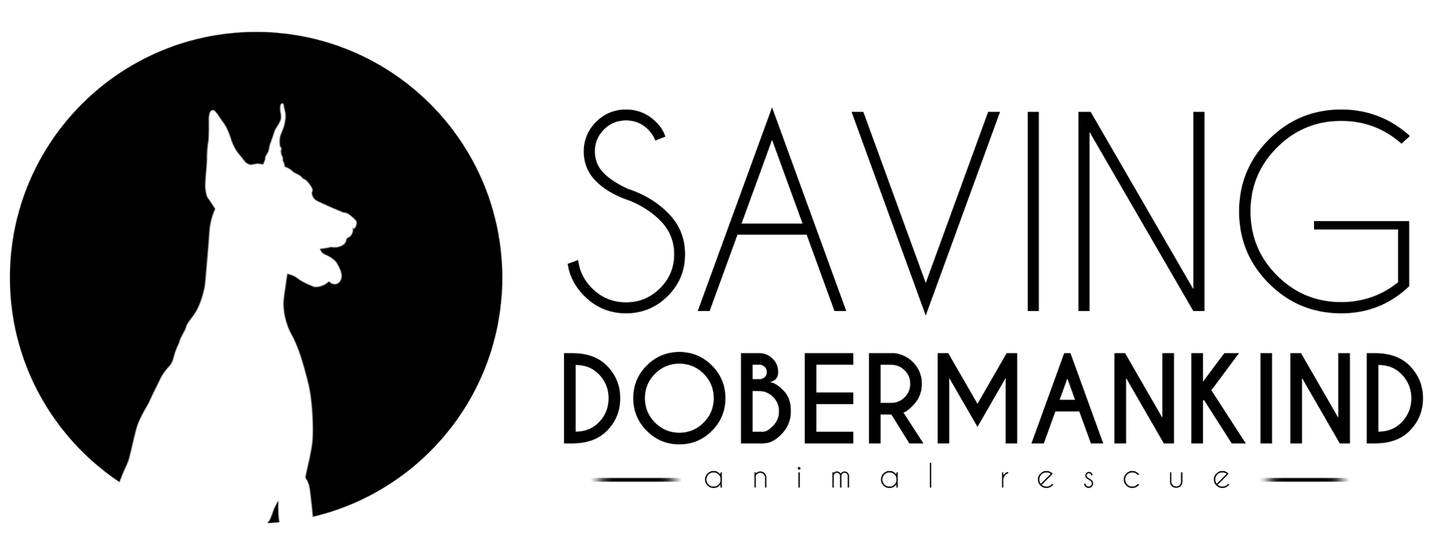

7486 Araia Dr, Fountain CO 80817
Phone (720) 722-4277
E-mail HookedOnDobies@gmail.com www.facebook.com/savingdobermankind
www.savingdobermankind.org
DOG ADOPTION CONTRACT
Please print legibly and fill out completely

This Adoption contract is entered into this day____________________, between Saving Dobermankind Animal Rescue (SDKAR) and ________________________________ (henceforth known as “Adopter(s)”.)
Saving Dobermankind Animal Rescue agrees to place for adoption the following described Dog:
Name of Dog: _________________ Breed of Dog: _______________________________
Sex: ______________ Color: ______________ DOB:____________________
Distinguishing Marks: __________________________ Rabies Tag Number: ____________
Microchip Number ______________________ Spayed/Neutered: Yes_____ No____ (if no Reason) ___________________________________________
- As mandated by Colorado law: If at the time of the adoption the animal is unaltered, the Adopter will pay a $50 spay/neuter deposit. The animal must be altered within 90 days of the Adoption Contract being signed_________________ or Saving Dobermankind Animal Rescue has the right to reclaim the animal. The $50 spay/neuter deposit will be refunded to the Adopter once proof of altering from a Veterinarian is provided.
Deposit Collected __________ Initials of Adopter ___________

1. Adopter agrees to pay a non-refundable adoption fee in the amount of $______ to help defer the costs of the rescue service.
2. Adopter agrees that the dog will be kept as a home companion and will share the Adopter’s home and be given the same consideration as any family member.
3. Adopter will not use, or allow the dog to be used for any illegal purpose.
4. Adopter agrees that the dog will not be attack trained and will not be used for guard work in any commercial endeavor.
5. If for any reason the Adopter is unable to keep the dog for its entire life, The Adopter MUST contact Saving Dobermankind Animal Rescue and make arrangements to return the dog to Saving Dobermankind Animal Rescue.
6. The Adopter agrees not to sell, give away, or dispose of the dog in any other manner (except for euthanasia for medical reasons at the advice of a licensed veterinarian), without prior consent in writing of Saving Dobermankind Animal Rescue.
7. Adopter agrees to keep a collar with the dog’s current rabies tag and identification, on the dog at all times when not at home.
8. Saving Dobermankind Animal Rescue has no knowledge of the temperament and behavior of the dog except as follows: __________________________________________________________________________________________________________________________________________________________________________
9. It is expressly understood that Saving Dobermankind Animal Rescue places the dog with no warranty as to the physical condition and temperament of the dog. The Adopter accepts the dog as is, with all defects, either observable or unobservable, and assumes all risk for the dog from the date of the signing of this contract.
10. The Adopter agrees to care for the dog in a humane manner, including but not limited to, providing adequate food, water, shelter, exercise, and veterinary care including necessary inoculations which includes keeping all vaccines up to date and within the standards of the state of Colorado, for the duration of the dog’s life, all in a manner satisfactory to Saving Dobermankind Animal Rescue
11. The Adopter agrees that under no circumstances is the dog to be routinely tethered as a means of confinement.
12. The Adopter agrees that the dog must be protected by being on a leash when outside a fenced enclosure and that at no time will the dog be transported in the open bed of a pick-up truck, or left in an enclosed vehicle when the outside temperature exceeds 75 degrees Fahrenheit.
13. The Adopter agrees that the dog will be confined in the house or garage when there is no one at home, except for prolonged absences such as vacations, when secure and proper care will have been prearranged for the dog.
14. The Adopter agrees to home visitation by a representative of Saving Dobermankind Animal Rescue as often as one time per month for the first three months following the effective date of this contract to determine if the adoption is successful. An annual visitation thereafter will be permitted if deemed necessary at the discretion of Saving Dobermankind Animal Rescue.
15. The Adopter agrees to notify Saving Dobermankind Animal Rescue of any change of address and/or phone number within two weeks of such change.
16. The adopter agrees that there will be no Cosmetic Surgical Alteration to the adopted animal. Examples of such procedures include, but are not limited to; Ear Cropping, Tail Docking, Prophylactic Dewclaw removal.
17. The Adopter agrees to notify Saving Dobermankind Animal Rescue immediately in the event this dog is lost or stolen, and at the time of its death
18. The Adopter assumes all responsibility for the dog’s actions after the effective date of the contract. The Adopter agrees to hold Saving Dobermankind Animal Rescue harmless for any actions of the dog after it is placed with the Adopter.
19. The Adopter agrees that the dog will not be subjected to second- and/or third-hand smoke on any regular basis.
20. The Adopter agrees to provide proof of vaccinations on any puppy that is still in need of shots at time of adoption, and understands that Saving Dobermankind Animal Rescue is not responsible for any shots given after the time of adoption.
21. Should the Adopter breach any of the agreements contained in this Adoption Contract, Saving Dobermankind Animal Rescue shall have the right to rescind this Adoption Contract and demand the return of the dog. Should the Adopter fail to return the dog, Saving Dobermankind Animal Rescue may seek an order from a Court of competent jurisdiction for the return of the dog.
22. This contract is to be governed by the laws of the state of Colorado.
Name(s) of Adopter(s) __________________________________________________________________________ Address___________________________________________________________________
City________________________________State_____________Zip ____________
Phone Number (Home) ______________ (Alternate) _______________________
Email Address ________________________________________________________________
Signature of Adopter(s) __________________________________________________________________________
Signature of Rescue Representative______________________________________________________________

PACFA Rabies Prevention Brochure Received □ Adopter Initials/Date ________________
Medical Records received by Adopter □ Adopter Initials/Date_______________________
Adoption Finalized? Yes □ No □ (reason why, if no)________________________________________ (SDKAR Rep Initials/Date)____________________________
Donation Received by (SDKAR Rep Initials/Date Check #_______/Cash /PayPal
Check cashed/Cash Deposited? Yes □ No □___________________________________

SDAR DOGS
Please note our organization is completely run by volunteers who do not get paid a single dime. We operate on donations and adoption fees. Adoption fees cover the spay/neuter, all vaccines, and microchipping of your new loved family member. Fees can also go towards additional medical care, transport of the dogs from high kill shelters to our volunteers, rescue insurance, food, bedding and anything else our rescue dogs need to ensure they are happy and healthy.

Our Adoption Fees:
- $450 for puppies (up to 6 months)
- $400 for young dogs (6 months to 2 years)
- $350 for adults (2 year to 6 years)
- $250 for seniors (7 years and older - may be reduced depending on the dog)

